Personal Finance Manager Design Document
1. Introduction
1.1 Purpose
This document describes the design of a console:based Personal Finance Manager application. The application lets users track their income, expenses, and budgets through a command:line interface, with all data persisted in MongoDB.
1.2 Scope
The application covers:
Expense management : add, view, filter by category/date, and delete
Income tracking : add and view income records
Budget management : set category:wise budget limits and track spending against them
Financial summary : total income, total expenses, balance, and category:wise breakdown
1.3 Technology Stack
Component | Technology
Language | Java
Runtime | JVM
Database | MongoDB
Interface | Console (CLI)

2. Use Case Diagram
The system has a single actor (the User) interacting with the finance manager through the console.
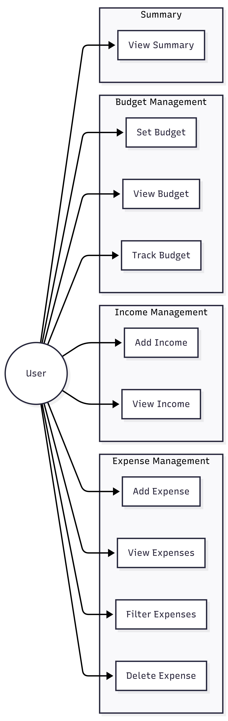

3. Architecture Design
The application uses a layered architecture. Each layer has a single responsibility and only talks to the layer directly below it.
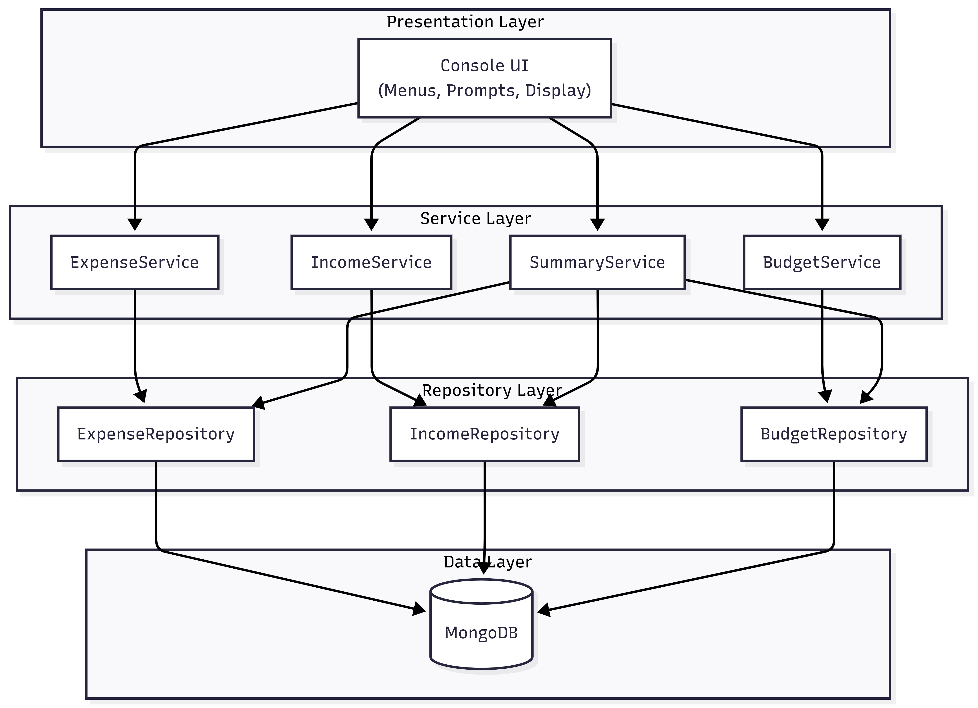
Layer Responsibilities:
Layer | What it does
Console UI | Takes user input, shows menus and results, handles I/O formatting
Service | Business logic, input validation, coordinating operations
Repository | Database CRUD operations, query building
Database | MongoDB stores the actual data in collections

4. ER Diagram
The database has three collections. While MongoDB is schema:less, we enforce a logical schema at the application level.
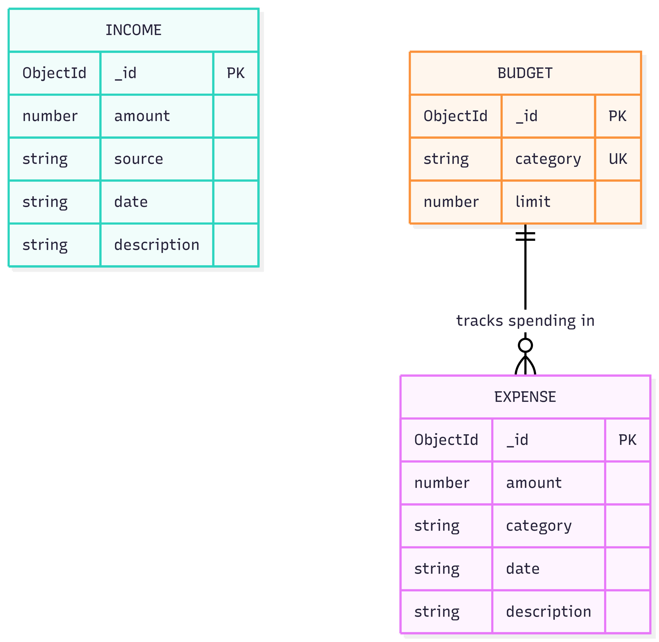

5. Class Diagram
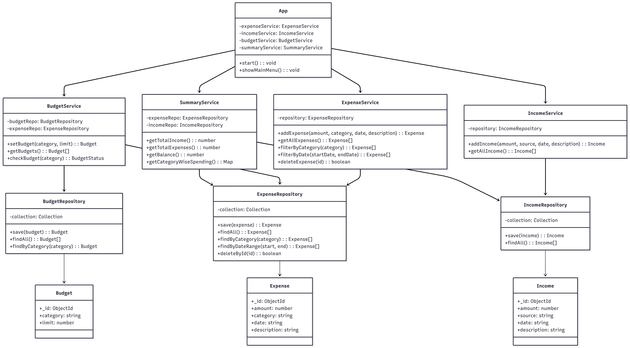
6. Module Design
6.1 Expense Module
Add expense : takes amount, category, date, and description from user
View all expenses : lists every recorded expense
Filter expenses : by category or by date range
Delete expense : removes a specific record by ID
6.2 Income Module
Add income : takes amount, source, date, and description
View income : lists all income records
6.3 Budget Module
Set budget : assign a spending limit for a category
View budgets : show all configured budgets
Track budget : compare actual spending against the limit, warn if exceeded
6.4 Summary Module
Total income : sum of all income records
Total expenses : sum of all expenses
Balance : income minus expenses
Category:wise spending : grouped breakdown of expenses by category

7. Application Flow
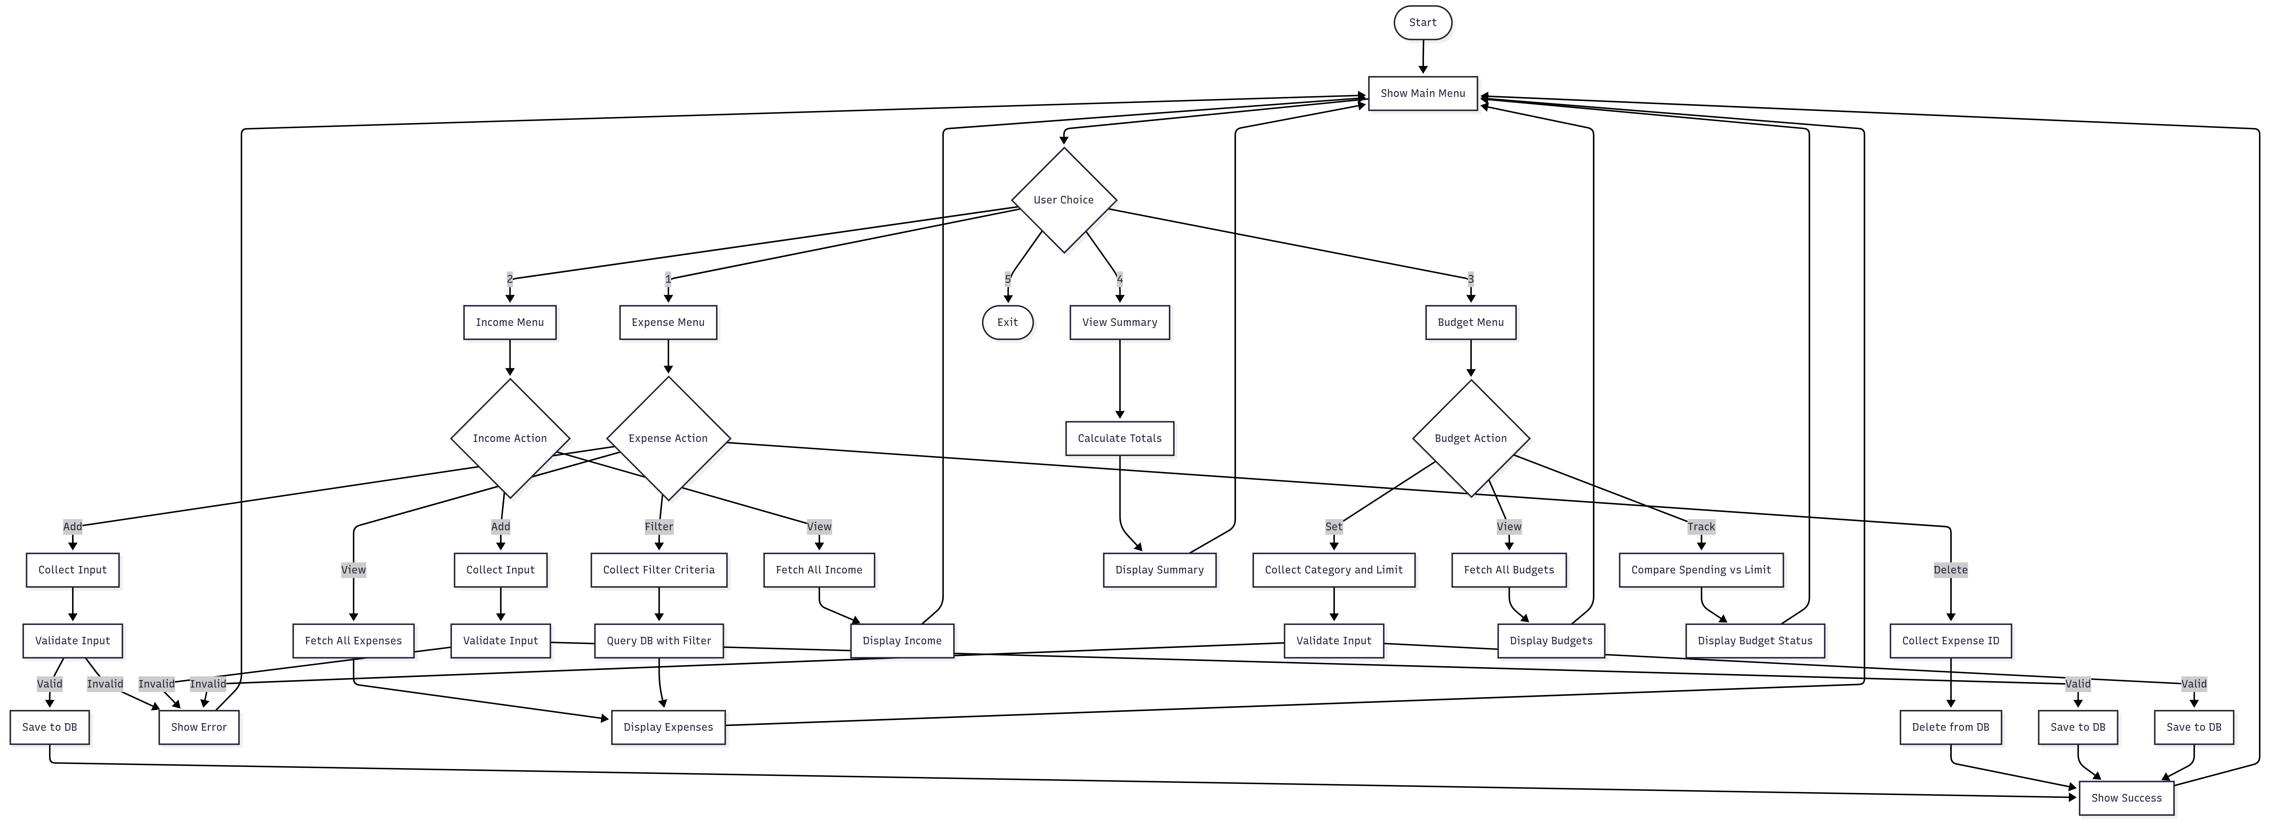
8. Design Principles Applied
Separation of Concerns : The UI, business logic, and data access are in separate layers. The console code never touches the database directly.
Single Responsibility : Each service handles one domain (expenses, income, or budgets). Each repository handles data access for one collection.
Open/Closed : New features (e.g., adding a "Savings" module) can be built as new service + repository pairs without modifying existing code.
Dependency Inversion : Services depend on repository interfaces, not concrete implementations. This makes it possible to swap MongoDB for another database later.
DRY : Common validation logic is extracted into reusable functions. Shared patterns like CRUD operations follow a consistent structure.
Loose Coupling : Layers communicate through well:defined method signatures. Changing the database or the UI framework wouldn't require rewriting the business logic.

9. Test Coverage Plan (Concise)

1. Expense Module
Add: Verify successful insertion with valid data. Verify rejection of invalid inputs (negative amounts, missing fields, future dates).
View: Verify all expenses are listed accurately.
Filter: Verify correct results when filtering by a specific category or date range.
Delete: Verify an expense is removed successfully using its ID.

2. Income Module
Add: Verify income is recorded correctly. Verify validation handles bad data.
View: Verify correct display of all income records.

3. Budget Module
Set: Verify budget limit is saved for a category.
View: Verify configured budgets are displayed properly.
Track: Verify no warning when under budget. Verify warning is triggered when spending exceeds the limit.

4. Summary Module
Calculations: Verify total income, total expenses, and balance (Income - Expenses) are calculated accurately.
Breakdown: Verify category-wise spending groups and sums expenses correctly.

5. Integration Tests
Verify that adding/deleting an expense dynamically updates the summary and budget tracking properly.

